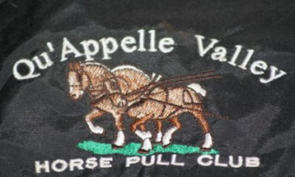
Qu’Appelle Valley Horse Pull Club
2016 Horse Pull Schedule

Date | Location | Time | Notes
June 17 | Pilot Butte | 8:00pm
June 26 | Bell Barn IH
July 3 | Arcola
July 6 | Weyburn | 12:00pm
July 9 | Ogema | 2:00pm
July 14,15,16 | Calgary
July 24 | Minot
July 30-31 | Swan River, MB |  | http://www.northwestroundup.ca/
August 6 | Findlater |  | http://www.findlaterranchrodeo.com/
August 6 | Nokomis | 6:00pm
August 13 | Stockholm | 2:00pm
August 14 | Robblin, MB | 12:30 MB Time
Sept. 3 | Jack Grad’s | 9:00am
For more information call 306-536-6189 or e-mail QVHPC@yahoo.ca
Visit our website at http://qvhpc.yolasite.com

“Preserving Our Draft Horse Heritage
By Moving Forward
One Load At A Time”

